## Docker networking

Below listed down 3 types of network Docker uses:

1. Bridge (Default. Mostly used Network in docker)
2. Host (network from host machine where docker is installed. Not recommended as it exhausts the IP’s of the Host subnet)
3. None (no network is provided. This container cannot communicate with any machine. Used to perform MALICIOUS application.)

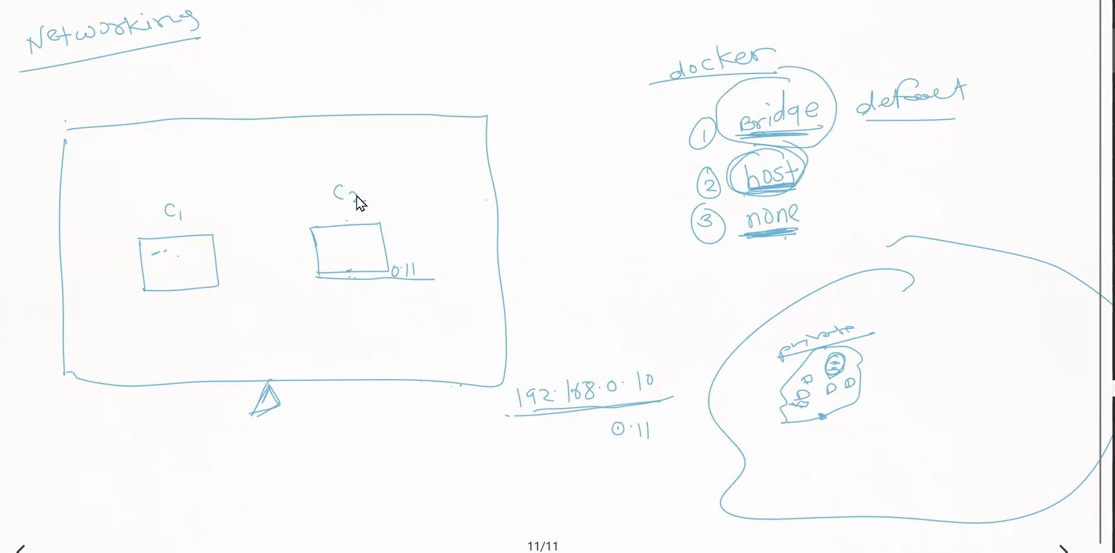

### Important Commands for Docker network

1. To see List of Docker networks🡪 docker network ls
2. To see more details about each network 🡪 docker network inspect<network-name>

e.g. docker network inspect bridge

1. To see the interfaces on host Linux machine🡪 ifconfig
2. If the above command not supported install the ‘net-tools’ package🡪 sudo apt install net-tools
3. Start container using command=🡪 docker run -d –name <container-name> -p 8000:8080 image-name:1.0 (once started do the inspect on bridge network to see this container added on bridge network )
4. To go inside container🡪 docker exec -it <container-name> bash
5. Inside the container run ifconfig to see IP address allocated to the container
6. We can use bridge network to create subnet and run containers in each subnet which will have default connectivity with each other within subnet. And subnet to subnet connectivity can be provided using bridge network.

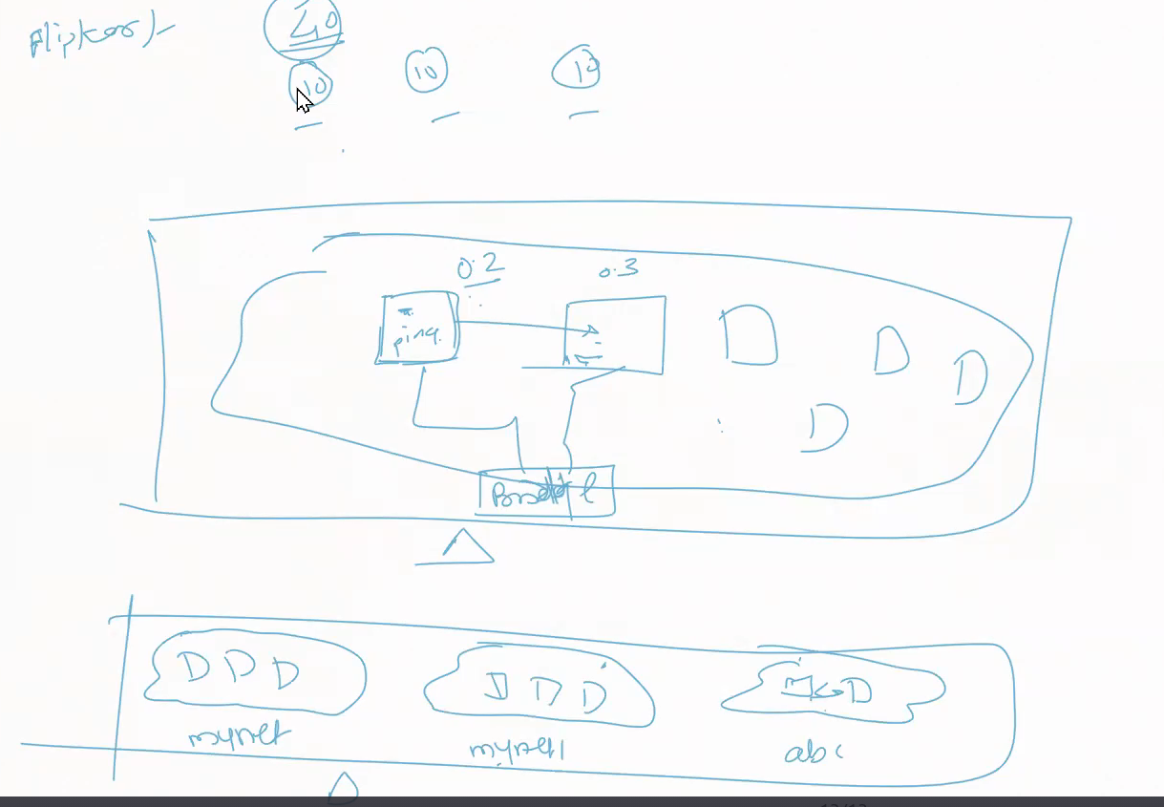

1. To create new network🡪 docker network create <network-name> --subnet=192.168.0.0/16
2. To run container on specific network🡪 docker run -d –name <container-name> -p 8001:8080 **–network <network-name>** <image-name:1.0>
3. To confirm the container got created on specified network run a command 🡪 docker network inspect <network-name>
4. Below diagram depicts how a container C1 from bridge network can connect to mynet hence C3 C4 containers in mynet 🡪 docker network connect <network-name> <container-name>

In this case🡪 docker network connect mynet c1

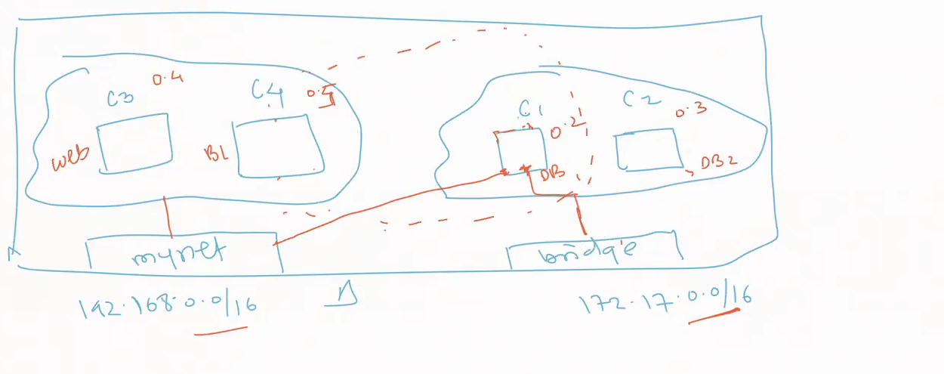

1. If you want to disconnect 🡪 docker network disconnect <network-name> <container-name>

## Docker Compose